Task 1

Code:

html.H1('Airline data Performance delay KPI btw 2005-2020',

                                        style={'textAlign':'center', 'color':'#503D36', 'font-size':24}

                                ),

Result:

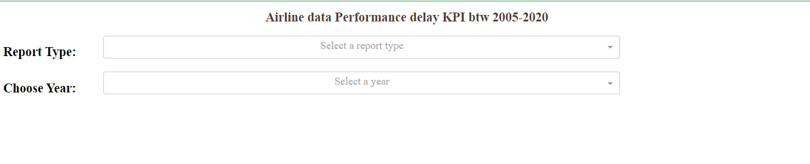

Task 2

Code:

dcc.Dropdown(id = 'input-type',

                                                    options=[

                                                            {'label': 'Yearly Airline perf report', 'value': 'OPT1'},

                                                            {'label': 'Yearly Airline delay report', 'value': 'OPT2'}

                                                    ],

                                                    placeholder = 'Select a report type',

                                                    style={'width':'80%', 'padding':'3px', 'font-size': '20px', 'text-align-last' : 'center'}),

Result:

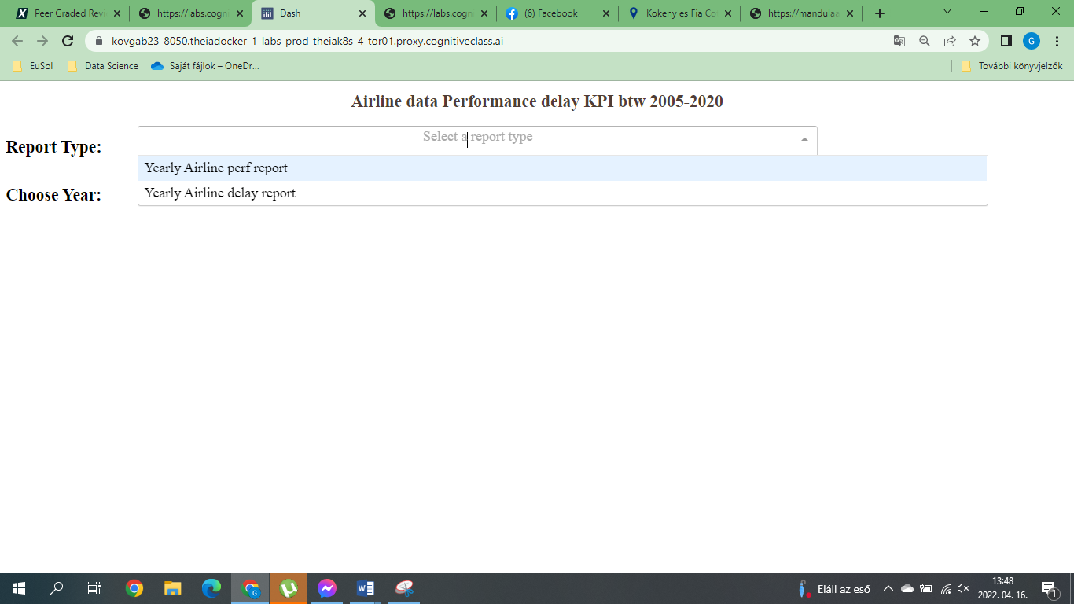

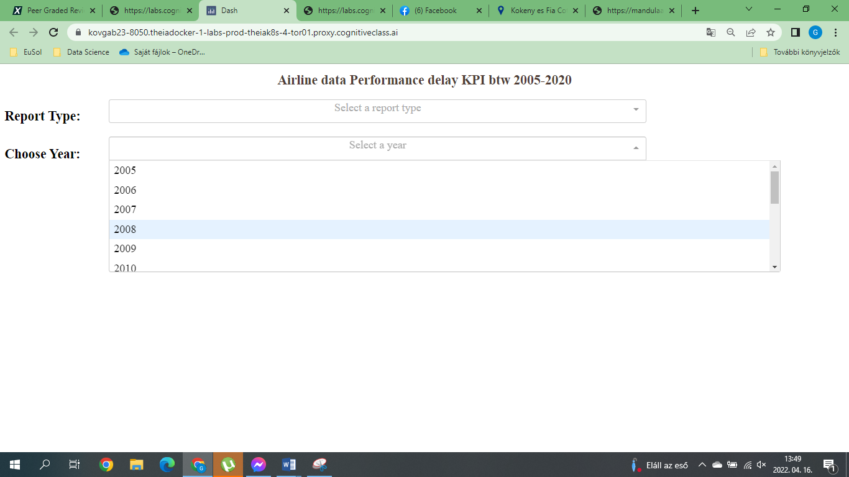

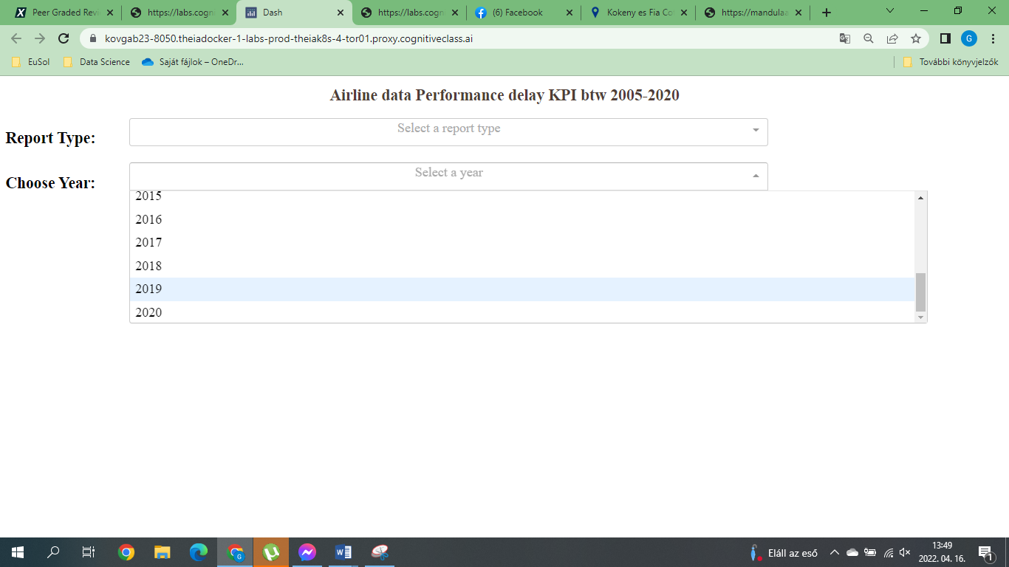

Task 3

Code:

NA

Result:

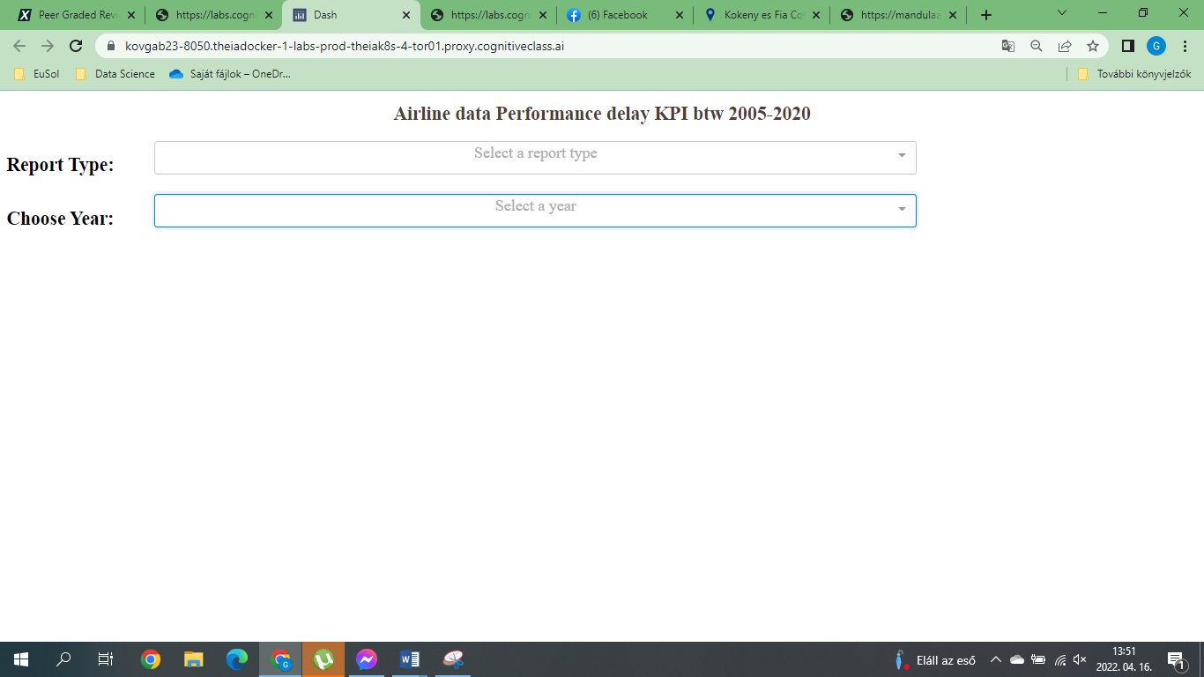

Task 4

Code:

NA

Result:

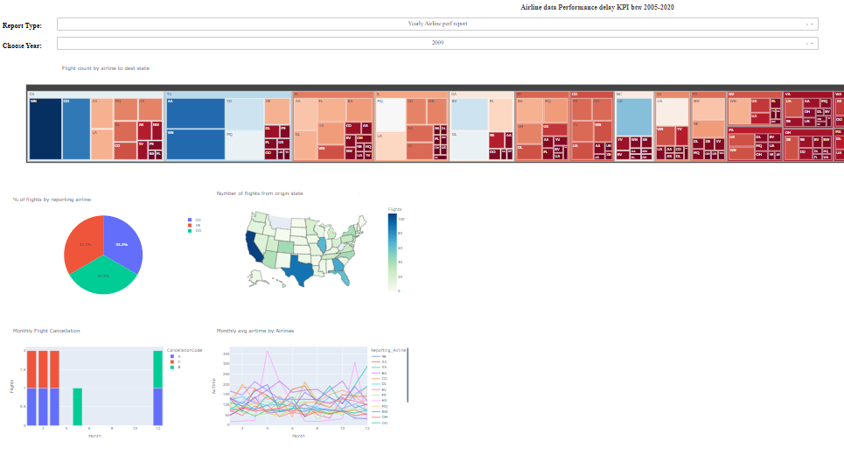

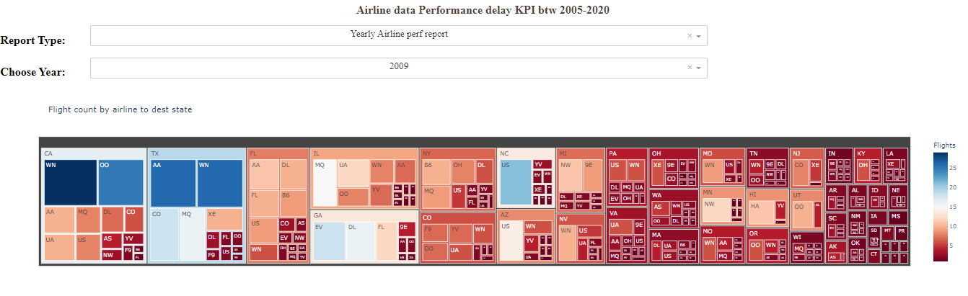

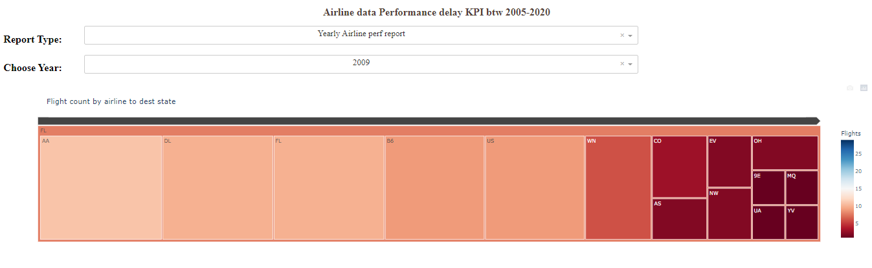

Task 5

Code:

Result:

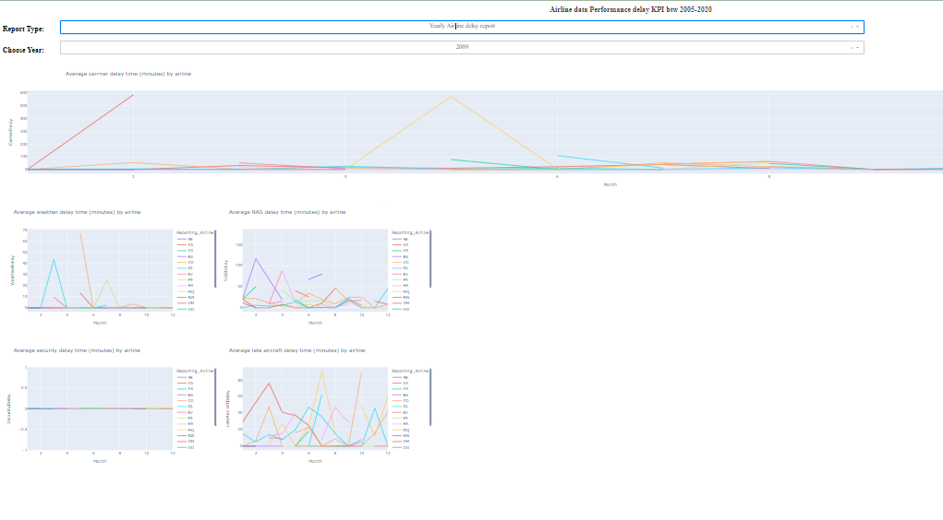

Task 6

Code:

Result:

